SUMMER PROGRAM IN VALLADOLID, SPAIN - 2019
LANGUAGE CLASSES - VALLADOLID and ESCUL offer their program in Valladolid, Spain exclusively for families participating in the Spanish Workshop. We will be glad to host parents and children wishing to learn Spanish in an intensive, yet fun language course! | 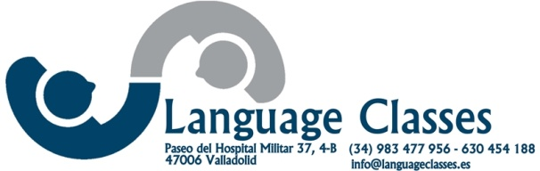

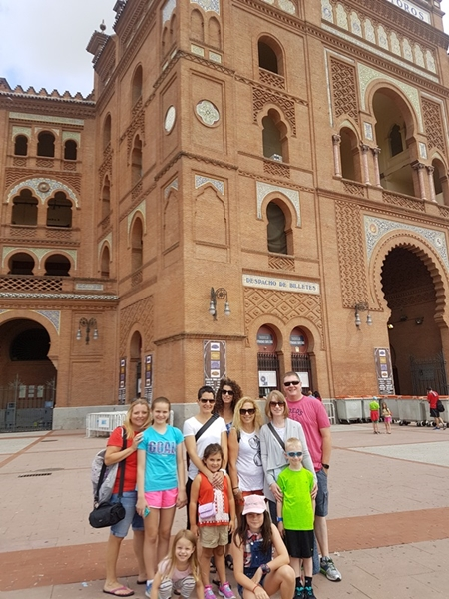 | Preliminary Itinerary  Program is subject to changes depending on the number of participants, local events and their interests.  Families are expected to arrive in Madrid on July 4 and leave from Madrid on July 21.

July 4  Families will be met at the airport and taken to the hotel in Madrid. Depending on the time of arrival there will be time to rest and in the afternoon we will begin exploring the city.  July 5  After breakfast we will go on a bus tour of the city to visit the main sights and monuments.  We will visit the Prado museum and have time to go shopping.  July 6  We will spend the morning at the Royal Palace and after lunch we will have time to explore the city on our own.  July 7  In the morning we will go to the Rastro, the Sunday flea market and after lunch we will leave by charter bus for Valladolid | 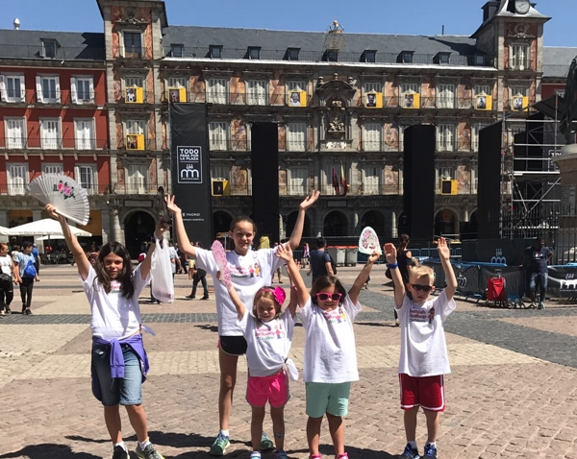

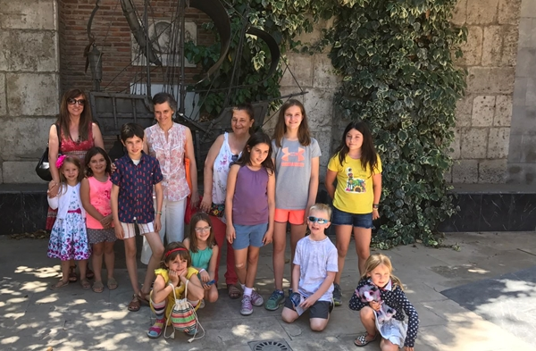 | July 7  Upon arrival in Valladolid, we will settle in our apartments and rest and get ready for the VINO ESPAÑOL DE BIENVENIDA, where we will meet the program staff and teachers.

July 8-12  We will have our classes every morning. Each group will meet with two different teachers in the morning and there will be two afternoons for workshops with local experts. We will visit one of the many museums available in the city. | 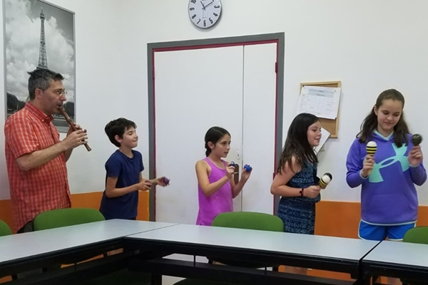

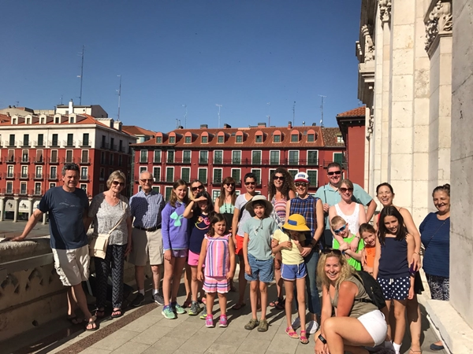 | July 13  We will spend the day in Salamanca, a World Heritage Site full of monuments and beautiful places. Our local guide will show us all of the main sites and, after lunch, we will have time to explore the city, go shopping or have ice cream or coffee at the Plaza Mayor.  July 14  We will travel to Segovia, to visit the city, another World Heritage Site, famous for its Roman Aqueduct and its Castle. A local guide will take us along to show us the main sites. We will have a special traditional lunch at a local restaurant where the Chef will demonstrate his art for us. After some time for shopping, we will return to Valladolid.
July 15-20  We will have our classes every morning. Again, each group will meet with two different teachers in the morning and there will also be two afternoons for workshops with local experts. We will visit the City Hall and meet with some of the local authorities.  On Saturday, we will have time for final shopping and packing and we will have a farewell lunch with the staff and teachers. | 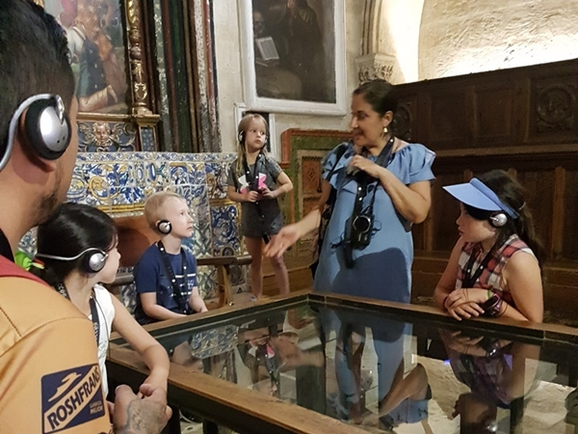

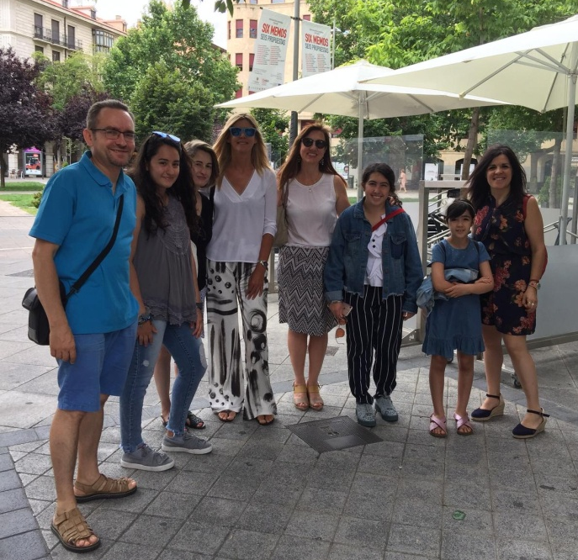 | July 21  A special bus will take us to the airport on time to check in for our return flights.

What are the program fees?  The program fee per person for the full program is based on a group of 15 participants with 4 hours of Spanish lessons per day, total of 20 hours per week.  For reservations received before December 31, 2018: 2,100.00 €  For reservations received before March 31: 2,200.00 €.  For reservations after March 31: 2,250.00 € | 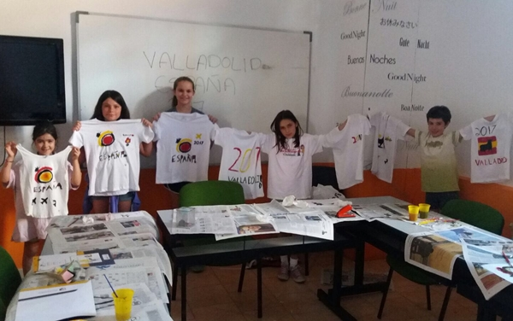

What is included in the fee?  The fee includes:  - Airport transfers  - Accommodation in Madrid, double rooms, with breakfast, upon arrival and for the city visit.  - Orientation session  - Madrid city visits and bus tour, entrance and guided visit to the Prado Museum and the Royal Palace  - Three meals in Madrid  - Accommodation in family apartments in Valladolid  - Spanish language program  - Four cultural workshops  - Visits in Valladolid as organized by the teachers  - Full day excursion to Salamanca with city visit with local guides and full lunch  - Day in Segovia with city visit with local guides and full lunch  - Entrance fees to museums as listed in preliminary program  - Medical and accident insurance  - Tour escort  Parents not participating in the language lessons can deduct 675.00 € from the program fee. | 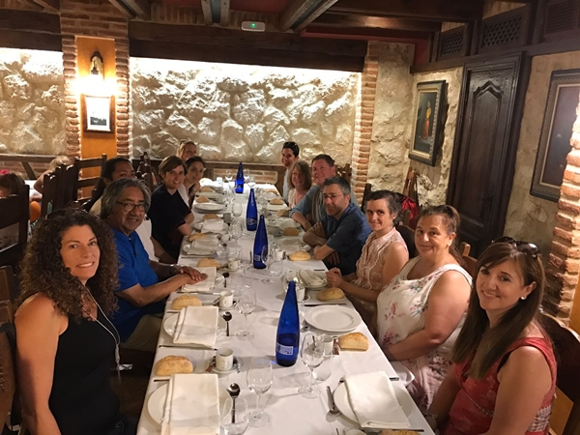

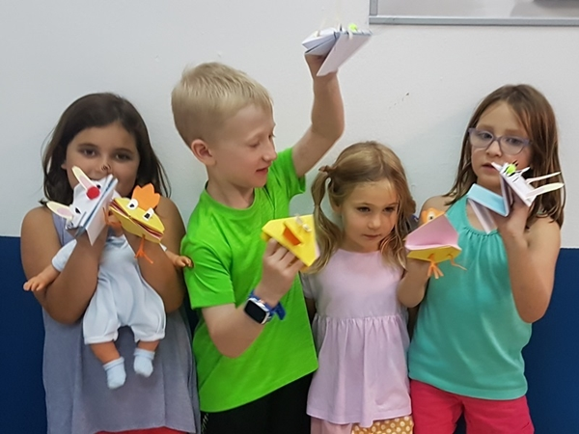 | How do I register?  You will need to fill out a registration form that you can download here.  A reservation fee of 250.00 € per is required. You can choose to pay via PAYPAL or by Credit Card.  The remaining portion of the program fee must be paid fifteen days before the program begins.

